**Disability Council NSW Applications open**

**About the Disability Council**

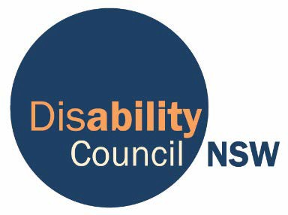The Disability Council NSW gives advice to the government, about things that are important to people with disability and their families.

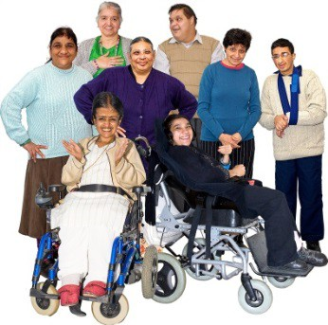

The Council has 8 to 12 members.

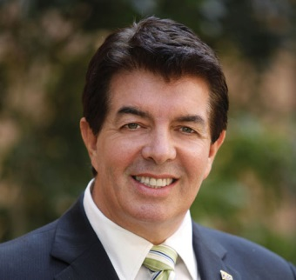

The Minister for Disability Services helps choose the members.

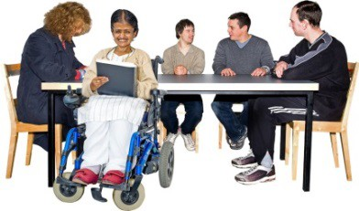Most of the members must be people with disability.

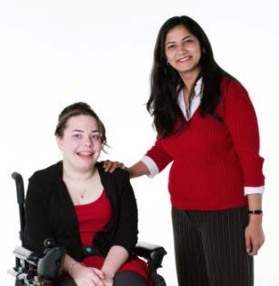

Two people lead the Council. They are called the Chair and Deputy Chair.

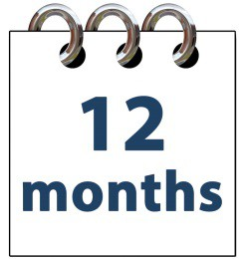

They are chosen from the members.

They have these jobs for up to 12 months.

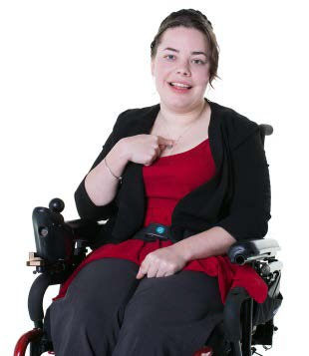The Chair must be a person with disability.

**Would you like to be a member?**

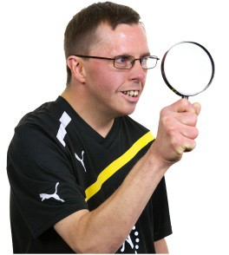We are looking for people who are interested in being a member of the Disability Council NSW.

You might be:

• a person with disability

• someone else in the community.

We also want the following groups of people:

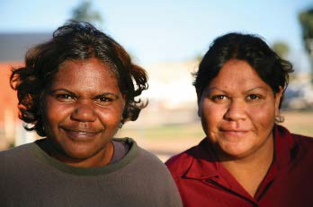• Aboriginal and Torres Strait Islander people

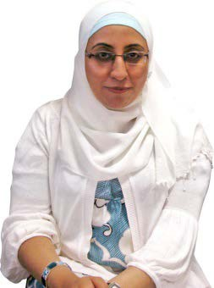

* people from different cultures, or who speak other languages at home

* young people and older people
* people who are gay, lesbian, bisexual, trans or intersex

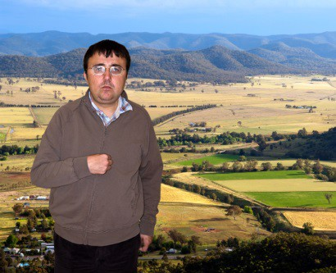

• people living in rural NSW as well as the city.

**How to apply**

1. Read the information in our Easy Read Info Pack at [www.disabilitycouncil.nsw.gov.au](http://www.disabilitycouncil.nsw.gov.au/__data/assets/word_doc/0008/419390/2017-Info-Pack-Easy-Read.DOCX)
2. On a computer, go to <https://nswcommunities.smartygrants.com.au/disabilitycouncilnsw2017>. Answer all the questions. NOTE: This link will only work after 17 June 2017

**You need to answer all the questions and submit your application by 5pm Sunday 30 July 2017.**

If you don’t have a computer, or can’t use a computer well, or need any other help to apply, contact the Disability Council:

**(02) 8879 9100**

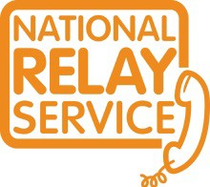If you have a hearing or speech impairment, you can contact us through the National Relay Service.

 [DisabilityCouncil@facs.nsw.gov.au](mailto:DisabilityCouncil@facs.nsw.gov.au)

**C:\Program Files (x86)\Microsoft Office\MEDIA\CAGCAT10\j0195384.wmf** [**www.disabilitycouncil.nsw.gov.au**](http://www.disabilitycouncil.nsw.gov.au)